Louis Greiner, TUHH « Prozedurale Programmierung »’s project, Winter Semester 2020/2021

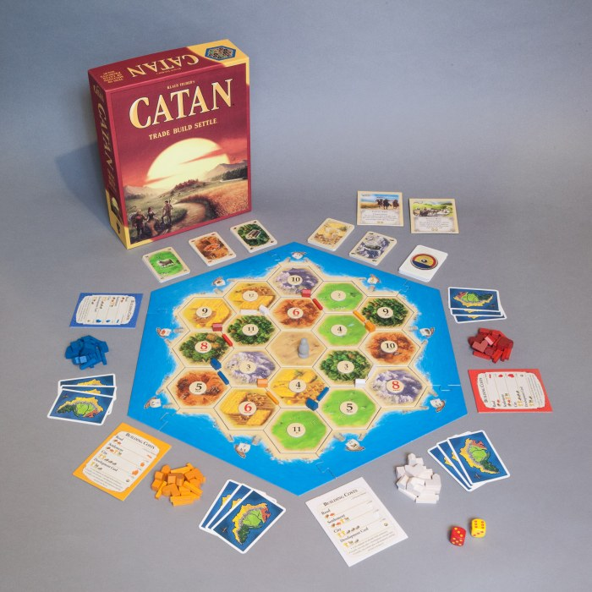The Settlers of Catan, version 0.1

The Settlers of Catan is a turn-based board game, which has been elected as the 1995 game of the year. Still famous today, many extensions and derivative games have been released since then. The purpose of this game is to build villages near resources area, gather resources, trade with your opponents, and gather a certain amount of victory points to end the game.

1. **Context background**

Picture yourself in the era of discoveries: after a long voyage of great deprivation, your ships have finally reached the coast of an uncharted island. Its name shall be Catan! But you are not the only discoverer. Other fearless seafarers have also landed on the shores of Catan: the race to settle the island has begun!

The women and men of your expedition build the first two settlements. Fortunately, the yet uninhabited land is rich in natural resources. You build roads and new settlements that eventually become cities. Will you succeed in gaining supremacy on Catan? Barter trade dominates the scene. Some resources you have in abundance, other resources are scarce. Ore for wool, brick for lumber - you trade according to what is needed for your current building projects. Proceed strategically! If you have set your settlements in the right places and skillfully trade your resources, then the odds will be in your favor. But your opponents are smart too.

1. **The basis**

To begin, the game board is built using hexagonal terrain tiles. Catan is born - a beautiful island with mountains, pastures, hills, fields, and forests, surrounded by the sea.

Each of you places two small houses on spaces where three terrain hexes meet. They are your starting settlements.

And so, it begins. You roll two dice. 5+6… an “11”! Each terrain hex is marked with a die roll number. Each player who owns a settlement adjacent to a terrain hex marked with the number rolled receives a resource produced by this hex. Hills produce brick, forests produce lumber, mountains produce ore, fields produce grain, and pastures produce wool.

You will use these resources to expand across Catan: you build roads and new settlements, or you upgrade our existing settlements to cities. For example, a road costs 1 brick and 1 lumber. If you do not have the necessary resources, we can acquire them by trading with your opponents.

Each settlement is worth 1 victory point and each city is worth 2 victory points. You can also earn victory points by buying development cards. If you expand cleverly, you may be the first player to reach 10 victory points and thus win the game!

1. **To do list**

The graphical display will be done with SDL. As I don’t know anything about it yet, it will maybe be time consuming.

I will try to get my code update, and save the previous versions, using Git.

The user has to be able to:

* Random-making the map, see it, the different tiles and the dice number associated
* Roll the dice
* Earn the resources associated with his villages / cities
* See a private panel about his personal resources (changing for each player)
* Build village where he wants, upgrade his villages in cities
* Trade with his own commercial ports
* Play with one or more player on the same computer
* Win when he hits 10 victory points

1. **Program structure**

A game will proceed as follows:

* Setup part:
  + Random-making the map
  + Players choose their color
  + Player 1 builds a village where he wants, then player 2, then player 3, then player 3 builds a second village, then player 2, then player 1 (for 3 players for example)
  + Each player receives resources depending on his first two settlements
* Player’s round:
  + Roll the dice (two 1-6 dice)
  + Distribution of the different resources associated at the previous dice roll result (concern all the players)
  + Possibility of trading (with the player’s commercial port, or a “4 same cards for 1” trade)
  + Building colony or city

The cards are limited:

* Resources cards (first stored in the bank):
  + 19 wood
  + 19 wheat
  + 19 ore
  + 19 wool
  + 19 clay
* Tiles:
  + 4 forests (produce wood)
  + 4 lands (produce wheat)
  + 3 mountains (produce ore)
  + 4 pastures (produce wool)
  + 3 hills (produce clay)
  + 9 commercial ports (trade resources for the player who owns it)
  + 9 open sea tiles (the 18 see tiles are placed outside peripheral)
  + 1 desert (produces nothing, and is always placed at the center of the map)
* Builds:
  + Colony (or village): 1 wood + 1 clay + 1 wheat + 1 wool (produces 1 resource depending on adjacent tiles, and gives 1 victory point)
  + City (transforms a village in city): 2 wheats + 3 ores (produces 2 resources depending on adjacent tiles, and gives 1 more victory point, so 2 in total with the previous colony)
* Players’ pawns:
  + 5 colonies
  + 4 cities

Different structures will be needed to represent:

* tiles(int ID_tile, int resource_type)
* player(int ID_player, char name, int player_resources[6])
* resources(int ID_owner, int resource_type, int value)
* pawn(int ID_pawn, int pawn_type, int ID_player)

Many functions will be involved:

* setup(int number_players)
  + generateMap() output an 1D-array that stores the map
  + chooseCharacter() player can choose a character, and its color that will be displayed on the map
  + setupColonies() the 2 first settlements
  + setupResources() gives resources of the 2 first settlements to every players
* round(struct player)
  + rollDice() will be called every round, then will distribute the resources for all players (don’t forget to update the bank)
  + resourcesDistribution()
  + while(player hasn’t press “END OF ROUND”)
    - askTrading() ask if the player wants to trade
    - trading() show all the possibilities of trade (commercial port or “4 to 1”)
    - askBuilding() ask if the player wants to build
    - building() show the possibilities of build
  + win() check if at the end of his turn, a player has won already or not
* general functions
  + fromMapToArray
  + displayPrivatePanel() show to the player his resources, actions he can do

Conventions:

* Resources
  + 0: wood
  + 1: wheat
  + 2: ore
  + 3: wool
  + 4: clay
  + 5: victory point
* ID and colors
  + 0: bank
  + 1: player 1 (RED color)
  + 2: player 2 (BLUE color)
  + 3: player 3 (YELLOW color)
  + 4: player 4 (GREEN color)
  + 5: player 5 (WHITE color)
  + 6: player 6 (ORANGE color)
* Pawns
  + 0: road (not used yet)
  + 1: colony
  + 2: city

1. **The constraints**

The main difficulty will not be all the individual concepts (coordinate system, trading system, graphical display, the roads…), but how all the sub-systems will communicate with each other.

As it is an ambitious project for only 3-4 weeks by myself only, I have decided to first try to do a MVP (Minimal Viable Product). The simplified version will have:

* no development cards
* no interaction between players (no trading)
* no roads, only cities
* no bandit
* only “hot-seat” playable
* random map (no rule on how the tiles are set)

Of course, I am aware that the game will not be balanced, due to all of these constraints. But the long-term goal (maybe not released on the deadline) is to implement everything.

1. **More to come**

If the simplified version is released and works before the deadline, I will try to implement the rest of the options and rules that make the game more interesting. Development cards will be a big problem because it is about a lot of new, and very specific, rules. The trading system will be easier I think, because it is only a question, yes or no, and a transfer of resources, maybe a customed message from the sender and a response from the receiver, why he agrees or not. The roads will be the most difficult part, because it restrains the players to play only around their well-known area, the roads cannot cross itself, and it involves some new rules. The bandit is easy, it will just result as a new variable of the structure “tile”. A multiplayer version playable simultaneously on different devices is unrealistic for now. Set-up the map and its different tiles is only a chain of rules, but which has to be done carefully.

<https://www.catan.com/board-games>

<https://ludos.brussels/ludo-cocof/opac_css/doc_num.php?explnum_id=318>